Question:
1. Write code to create a simple line plot in Python using Matplotlib to predict sales happened in a month?
- Write code to create a scatter plot in Python using Matplotlib to predict sales happened in a month?
- 3. Develop a Python program to create a bar plot of the monthly sales data.

Program:

import matplotlib.pyplot as plt
sales=[20,15,10,25,30]
days=[1,2,3,4,5]
plt.plot(sales,days)
plt.xlabel("Sales")
plt.ylabel("Days")
plt.title("Sales in a store")
plt.show()

Output:

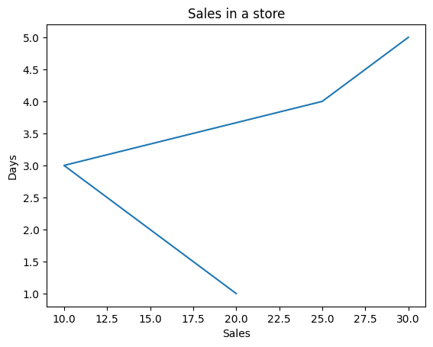

Program:

import matplotlib.pyplot as plt
sales=[100,200,300,400,600]
months=["Jan","Feb","Mar","Apr","May"]
plt.bar(months,sales)
plt.xlabel("Months")
plt.ylabel("Sales")
plt.title("Sales in a store")
plt.show()

Output:

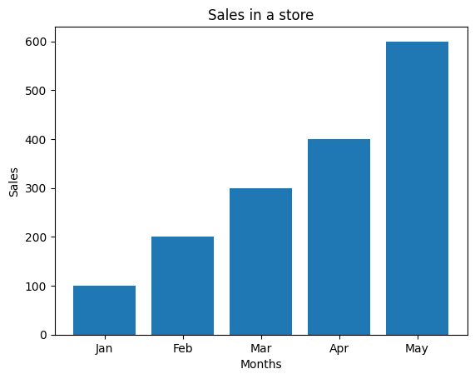
Program:

import matplotlib.pyplot as plt

temp = [30, 32, 35, 33, 31, 29, 28]
months = ["Jan","Feb","Mar","Apr","May","Jun","Jul"]

plt.plot(months, temp)
plt.xlabel("Months")
plt.ylabel("Temperature")
plt.title("Monthly Temperature")
plt.show()

Output:

